Churches complete the unique online Eco Survey about how they are caring for God’s earth in different areas of their life and work. The answers a church provides will collect points towards an Eco Church Award – the more your church does, the more points you get!

If your score doesn’t gain you an Eco Church Award straight away don’t worry – the idea is to complete further actions in order to gain the points necessary for an Award. For example, you can switch to a green energy company or start using Fairtrade tea and coffee supplies to gain Eco Church Award points.
The survey takes you through five key areas of church life:
- Worship and teaching
- Management of church buildings
- Management of church land
- Community and global engagement
- Lifestyle
It takes into account whether or not your church has buildings or land, and you can save your survey responses at any point and return to update them as your church completes additional actions.
Our free, Eco Church resources will give lots of support and advice about how to make the changes your church needs to become an Eco Church. There are three levels of Eco Church Award – Bronze, Silver and Gold. In order to qualify for an Award you must attain the required standard in each of the areas covered by the Eco Survey that apply to your church (some churches do not have buildings or land). You can see when you have gained sufficient points in each Eco Survey category by looking at the points gauges that appear on screen with the Eco Survey questions. The gauges will change colour as your points accumulate to reflect the level of Award you have achieved.
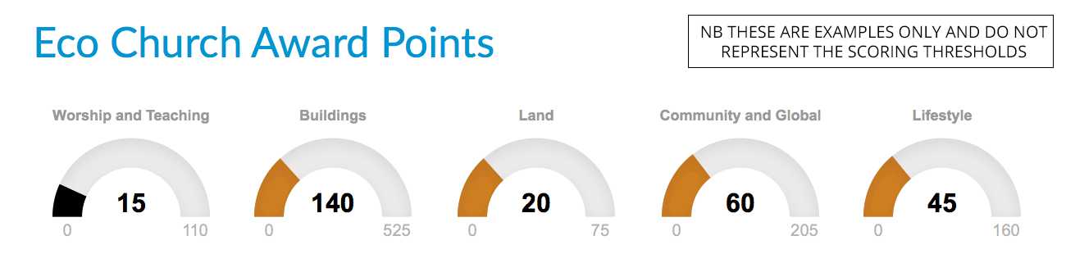
If all the relevant gauges turn bronze, you have achieved a Bronze Award; if they all turn silver you have achieved a Silver Award, and so on. However, if just some of your gauges turn silver while the others turn bronze, for example, you have achieved a Bronze Award (rather than a Silver Award) because that is the level you have achieved in all the relevant areas.
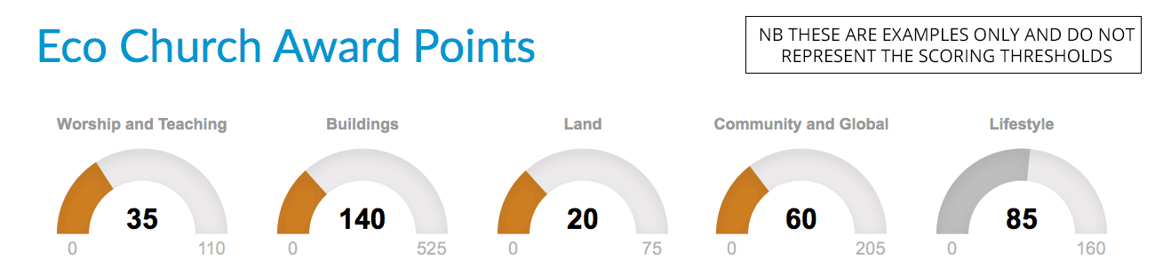
Once all the gauges on your Eco Survey indicate that you have enough points for an Award, you can apply for your Award by downloading and completing the Award Application Form. For Bronze and Silver Awards we will require confirmation from your church leader that they have seen and approved the Eco Survey responses provided on behalf of your church. Additionally, for Gold Awards we will arrange for an Eco Church Assessor to visit your church to see and hear for themselves of all that you’ve been doing to care for God’s earth across the areas covered by the Eco Survey.
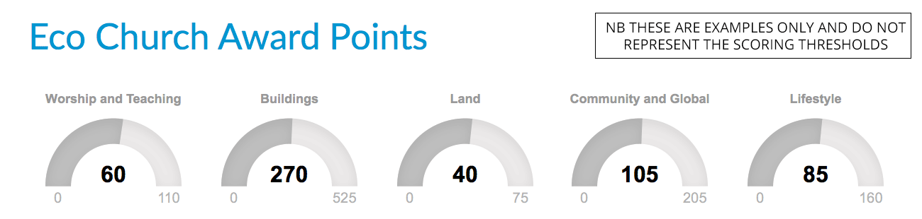
Once your Award is confirmed, you will receive a certificate and (optional) plaque from A Rocha UK to mark your achievement.
